Report for Game of Life

based on Genetic Algorithm

1、 Introduction

Our group use Genetic Algorithm to optimize the performance of Game of Life by design Mutation Function, Evolution Function and Fitness Function. Seed diagram which can generate children more than 1000 was found through these functions.

* 1. **Work flow**

**Invariant 1: Seed diagram can create several generations.**

step1: Input one seed diagrams in Game of life, and get the output of them.

step2: use fitness function to assess generation number, growth rate, stop reason.

step3: use mutation function and evolution function (GA) to optimize the diagrams’ genotype and phenotype.

step4: re-execute step 2,3 until the diagram meet the stop situation

**Invariant 2: obtain optimized seed diagram has more than 1000 generations**

**1.2 live cell data structure**

**Chromosome ( phenotype ) :**

Map(key, value) -----key: point; value: genotype. Each point has 1 bit binary digital（0/1)

**Genotype:**

3 bit binary digital（000, 001, 010, 011, 100, 101, 110, 111) genotype control the direction of phenotype.

|  |  |  |  |  |  |  |  |  |
| --- | --- | --- | --- | --- | --- | --- | --- | --- |
| Genotype | 000 | 001 | 010 | 011 | 100 | 101 | 110 | 111 |
| phenotype change | x-1，y+1 | y+1 | x+1，y+1 | x-1 | x+1 | x-1，y-1 | y-1 | x+1，y-1 |

**Diagram size:** 40*40

**Seed size:**1000 (phenotype 0: phenotype 1=1:1)

**1.3 Fitness Function, Mutation Function and growth function**

**Fitness function:** use behavior function to assess generation number, growth rate, stop reason.

**Mutation function：**select one random slot in the genotype and change it into the opposite binary digital.

**Evolution function：**

growth rate =  live cells of this generation - live cells of previous

if growth Rate < 0.1 or the number of live cell < 20, then execute Mutation Function before Game of Life;

others, execute only Game of Life

**1.4 terminate situation**

**situation 1**：generation number up to 1000

**situation 2**：no life cell exist

**1.5 User Interface operation**

After running the project, click “Choose pattern” and select “pattern.txt”. Then click start.

2、 Observation

2.1 Diagram before Game of Life ( without GA )

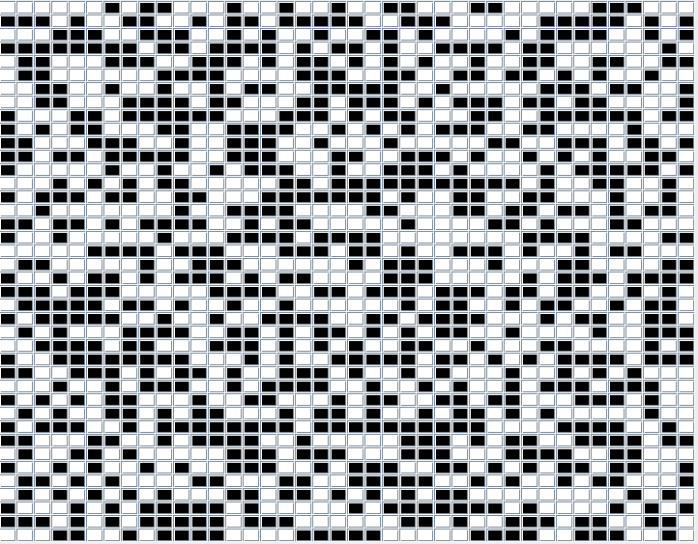

2.2 Diagram after Game of Life ( without GA ) 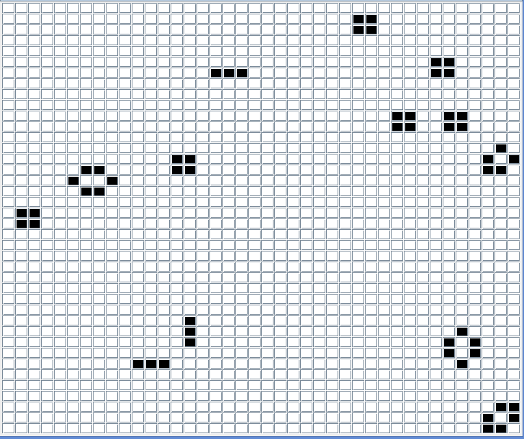

2.3 Diagram before Game of Life( GA )

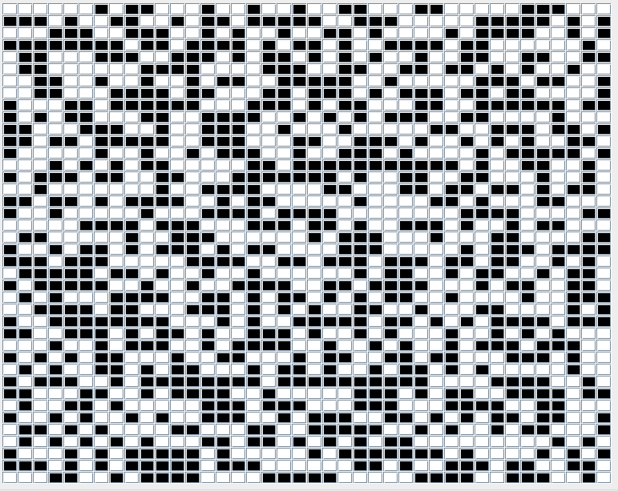

2.4 Diagram after Game of Life ( GA )

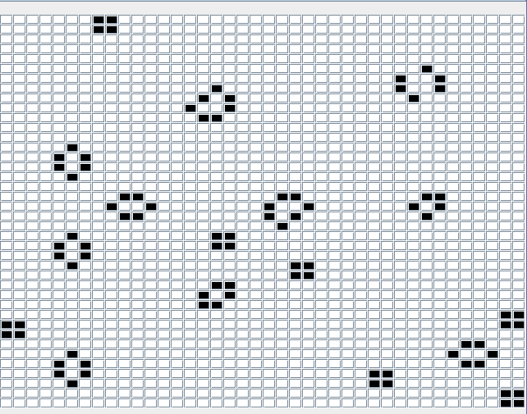

Without Genetic Algorithm, the output diagram concludes 56 points, and with Genetic Algorithm, the output diagram concludes 85 points. The evolution function and mutation function effectively optimize the performance of Game of Life.

3、 Conclusion

GA can effectively optimize the performance of Game of Life by increase the offspring number or random mutation. It can help every generation to create more points and have more chance to fit the fitness function.